SYNOPSIS

ON

“Face Detection”

Submitted in

Partial Fulfillment of requirements for the Award of Degree

*of*

Bachelor of Technology

*In*

Computer Science and Engineering

By

**(Project Id: 2A05 )**

# Amit Gupta (1901640100045)

**Anubhav Bajpai (1901640100064)**

Under the supervision of

**Neha Singh**

**(Assistant Teacher)**



**Pranveer Singh Institute of Technology**.

 Kanpur - Agra - Delhi National Highway - 2

Bhauti -Kanpur - 209305.

(Dr. A.P.J. Abdul Kalam Technical University)

**Synopsis**

Introduction

Face recognition has been one of the most interesting and important research fields in

the past two decades. The reasons come from the need of automatic recognitions and

surveillance systems, the interest in human visual system on face recognition, and the

design of human-computer interface, etc. These researches involve knowledge and

researchers from disciplines such as neuroscience, psychology, computer vision,

pattern recognition, image processing, and machine learning, etc.

The goal of this effort is to develop new algorithms

for a robust pose-invariant face recognition that overcome many of the limitations

found in existing facial recognition systems. Specifically, we are interested in

addressing the problem of detecting faces in color images in the presence of various

lighting conditions and complex backgrounds as well as recognizing faces under

variations in pose, lighting, and expression. This work is separated into two major

components (i) Face detection and (ii) Face recognition. Specific tasks include

developing modules for face detection, pose estimation, face modeling, face

matching, and a user interface.

Project Objective

There are few objectives to design face detection system. The objective of face detection are :

* To design real time face detection system.
* To utilize the face detection system based on Haar Classifier

Feasibility Study

The study determines if the new proposed system is useful to the organization or not.

The system does not count if it’s not useful to the organization. In parallel, the study

also determines if the system can be built correctly and precisely on time with available

resources meeting all the constraints.

Face Detection:

Is technically feasible since user only require web camera to use the system. Similarly,

it is operationally feasible because this system is easy to use. And the system is

economically feasible because we don’t require money to use it since it can be

downloaded free of cost on mobile and used.

Face detection has been one of the most interesting and important research fields in the past two decades. The reasons come from the need of automatic recognitions and surveillance systems, the interest in human visual system on face detection, and the design of human-computer interface, etc. These researches involve knowledge and researchers from disciplines such as neuroscience, psychology, computer vision, pattern recognition, image processing, and machine learning, etc. A bunch of papers have been published to overcome difference factors (such as illumination, expression, scale, pose, ……) and achieve better recognition rate, while there is still no robust technique against uncontrolled practical cases which may involve kinds of factors simultaneously. In this report, we’ll go through general ideas and structures of recognition, important issues and factors of human faces, critical techniques and algorithms, and finally give a comparison and conclusion. Readers who are interested in face recognition could also refer to published surveys [1-3] and website about face detection [4]. To be announced, this report only focuses on color-image-based (2D) face recognition, rather than video-based (3D) and thermal-image-based methods.

From this section on, we start to talk about technical and algorithm aspects of face recognition. We follow the three-step procedure depicted in fig. 1 and introduce each step in the order: Face detection is introduced in this section, and feature extraction and face recognition are introduced in the next section. In the survey written by Yang et al. [7], face detection algorithms are classified into four categories: knowledge-based, feature invariant, template matching, and the appearance-based method. We follow their idea and describe each category and present excellent examples in the following subsections. To be noticed, there are generally two face detection cases, one is based on gray level images, and the other one is based on colored images.

4.1 Knowledge-based methods:

These rule-based methods encode human knowledge of what constitutes a typical face. Usually, the rules capture the relationships between facial features. These methods are designed mainly for face localization, which aims to determine the image position of a single face. In this subsection, we introduce two examples based on hierarchical knowledge-based method and vertical / horizontal projection.

4.1.1 Hierarchical knowledge-based method:

This method is composed of the multi-resolution hierarchy of images and specific rules defined at each image level [8]. The hierarchy is built by image sub-sampling and an example is shown in fig. 9. The face detection procedure starts from the highest layer in the hierarchy (with the lowest resolution) and extracts possible face candidates based on the general look of faces. Then the middle and bottom layers carry rule of more details such as the alignment of facial features and verify each face candidate. This method suffers from many factors described in Section 3 especially the RST variation and doesn’t achieve high detection rate (50 true positives in 60 test images), while the coarse-to-fine strategy does reduces the required computation and is widely adopted by later algorithms.

4.1.2 Horizontal / vertical projection:

This method uses the fairly simple image processing technique, the horizontal and vertical projection [9]. Based on the observations that human eyes and mouths have lower intensity than other parts of faces, these two projections are performed on the test image and local minimums are detected as facial feature candidates which together constitute a face candidate. Finally, each face candidate is validated by further detection rules such as eyebrow and nostrils. As shown in fig. 10, this method is sensitive to complicated backgrounds and can’t be used on images with multiple faces.

4.2 Feature invariant approaches:

These algorithms aim to find structural features that exist even when the pose, viewpoint, or lighting conditions vary, and then use these to locate faces. These methods are designed mainly for face localization. To distinguish from the knowledge-based methods, the feature invariant approaches start at feature extraction process and face candidates finding, and later verify each candidate by spatial relations among these features, while the knowledge-based methods usually exploit information of the whole image and are sensitive to complicated backgrounds and other factors described in Section 3. We present two characteristic techniques of this category in the following subsections, and readers could find more works in [6][12][13][14][26][27].

4.2.1 Face Detection Using Color Information

In this work, Hsu et al. [10] proposed to combine several features for face detection. They used color information for skin-color detection to extract candidate face regions. In order to deal with different illumination conditions, they extracted the 5% brightest pixels and used their mean color for lighting compensation. After skin-color detection and skin-region segmentation, they proposed to detect invariant facial features for region verification. Human eyes and mouths are selected as the most significant features of faces and two detection schemes are designed based on chrominance contrast and morphological operations, which are called “eyes map” and “mouth map”. Finally, we form the triangle between two eyes and a mouth and verify it based on (1) luminance variations and average gradient orientations of eye and mouth blobs, (2) geometry and orientation of the triangle, and (3) the presence of a face boundary around the triangle. The regions pass the verification are denoted as faces and the Hough transform are performed to extract the best-fitting ellipse to extract each face. This work gives a good example of how to combine several different techniques together in a cascade fashion. The lighting compensation process doesn’t have a solid background, but it introduces the idea that despite modeling all kinds of illumination conditions based on complicated probability or classifier models, we can design an illumination-adaptive model which modifies its detection threshold based on the illumination and chrominance properties of the present image. The eyes map and the mouth map shows great performance with fairly simple operations, and in our recent work we also adopt their framework and try to design more robust maps.

Methodology

In the beginning of the 1970's, face recognition was treated as a 2D pattern recognition problem [2]. The distances between important points where used to recognize known faces, e.g. measuring the distance between the eyes or other important points or measuring different angles of facial components. But it is necessary that the face recognition systems to be fully automatic. Face recognition is such a challenging yet interesting problem that it has attracted researchers who have different backgrounds: psychology, pattern recognition, neural networks, computer vision, and computer graphics. The following methods are used to face recognition.

1. Holistic Matching Methods

2. Feature-based (structural) Methods

3. Hybrid Methods

1. Holistic Matching Methods: In holistic approach, the complete face region is taken into account as input data into face catching system. One of the best example of holistic methods are Eigenfaces [8] (most widely used method for face recognition), Principal Component Analysis, Linear Discriminant Analysis [7] and independent component analysis etc. 1.1.1 Holistic example. The first successful demonstration of machine recognition of faces was made by Turk and Pentland[2] in 1991 using eigenfaces. Their approach covers face recognition as a two dimensional recognition problem. The flowchart in Figure 1 illustrates the different stages in an eigenface based recognition system. (1) The first stage is to insert a set of images into a database, these images are names as the training set and this is because they will be used when we compare images and when we create the eigenfaces. (2) The second stage is to create the eigenfaces. Eigenfaces are made by extracting characteristic features from the faces. The input images are normalized to line up the eyes and mouths. They are then resized so that they have the same size. Eigenfaces can now be extracted from the image data by using a mathematical tool called Principal Component Analysis (PCA). (3) When the eigenfaces have been created, each image will be represented as a vector of weights. (4) The system is now ready to accept entering queries. (5) The weight of the incoming unknown image is found and then compared to the weights of those already in the system. If the input image's weight is over a given threshold it is considered to be unidentified. The identification of the input image is done by finding the image in the database whose weights are the closest to the weights of the input image. The image in the database with the closest weight will be returned as a hit to the user of the system.

2. Feature-based (structural) Methods: In this methods local features such as eyes, nose and mouth are first of all extracted and their locations and local statistics (geometric and/or appearance) are fed into a structural classifier. A big challenge for feature extraction methods is feature "restoration", this is when the system tries to retrieve features that are invisible due to large variations, e.g. head Pose when we are matching' a frontal image with a profile image. Distinguishes between three different extraction methods: I. Generic methods based on edges, lines, and curves II. Feature-template-based methods III. Structural matching methods that take into consideration geometrical Constraints on the features.

3. Hybrid Methods: Hybrid face recognition systems use a combination of both holistic and feature extraction methods. Generally 3D Images are used in hybrid methods. The image of a person's face is caught in 3D, allowing the system to note the curves of the eye sockets, for example, or the shapes of the chin or forehead. Even a face in profile would serve because the system uses depth, and an axis of measurement, which gives it enough information to construct a full face. The 3D system usually proceeds thus: Detection, Position, Measurement, Representation and Matching. Detection - Capturing a face either a scanning a photograph or photographing a person's face in real time. Position - Determining the location, size and angle of the head. Measurement - Assigning measurements to each curve of the face to make a template with specific focus on the outside of the eye, the inside of the eye and the angle of the nose. Representation - Converting the template into a code - a numerical representation of the face and Matching - Comparing the received data with faces in the existing database. In Case the 3D image is to be compared with an existing 3D image, it needs to have no alterations. Typically, however, photos that are put in 2D, and in that case, the 3D image need a few changes. This is tricky, and is one of the biggest challenges in the field today.

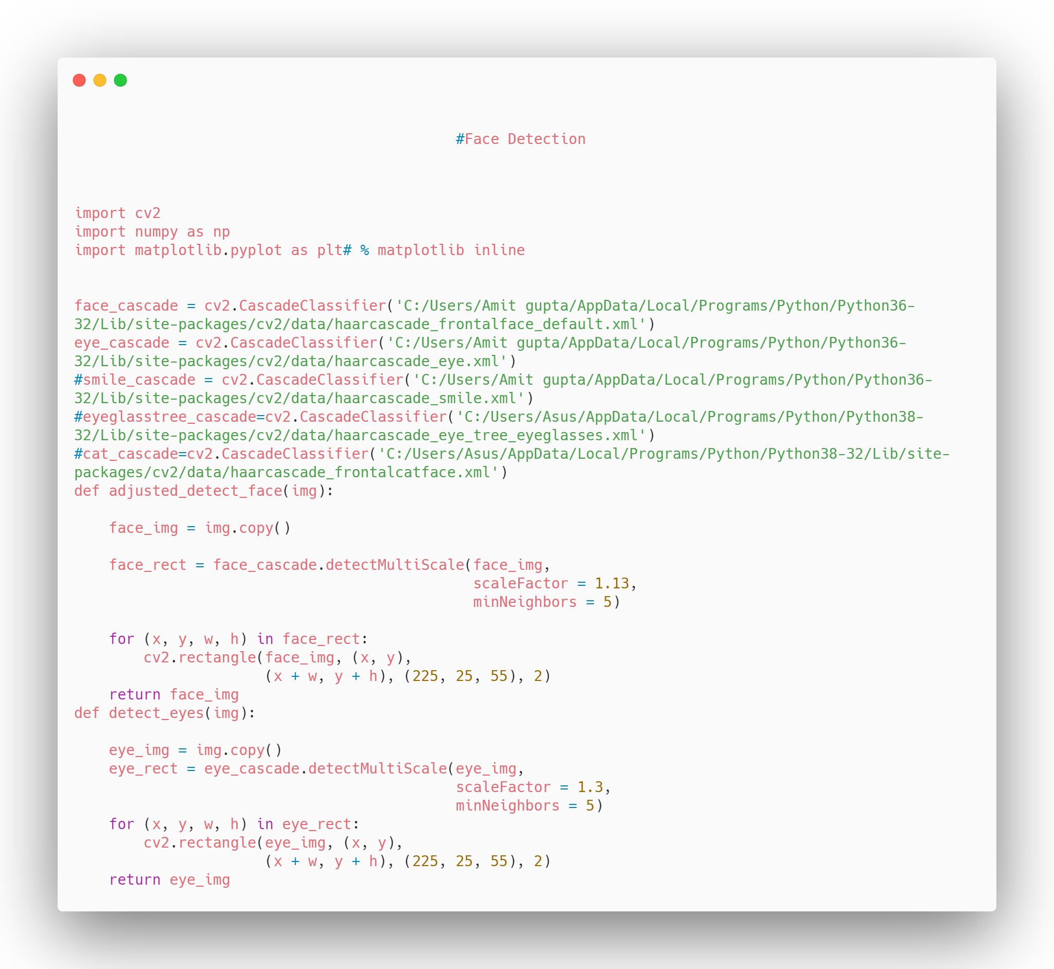

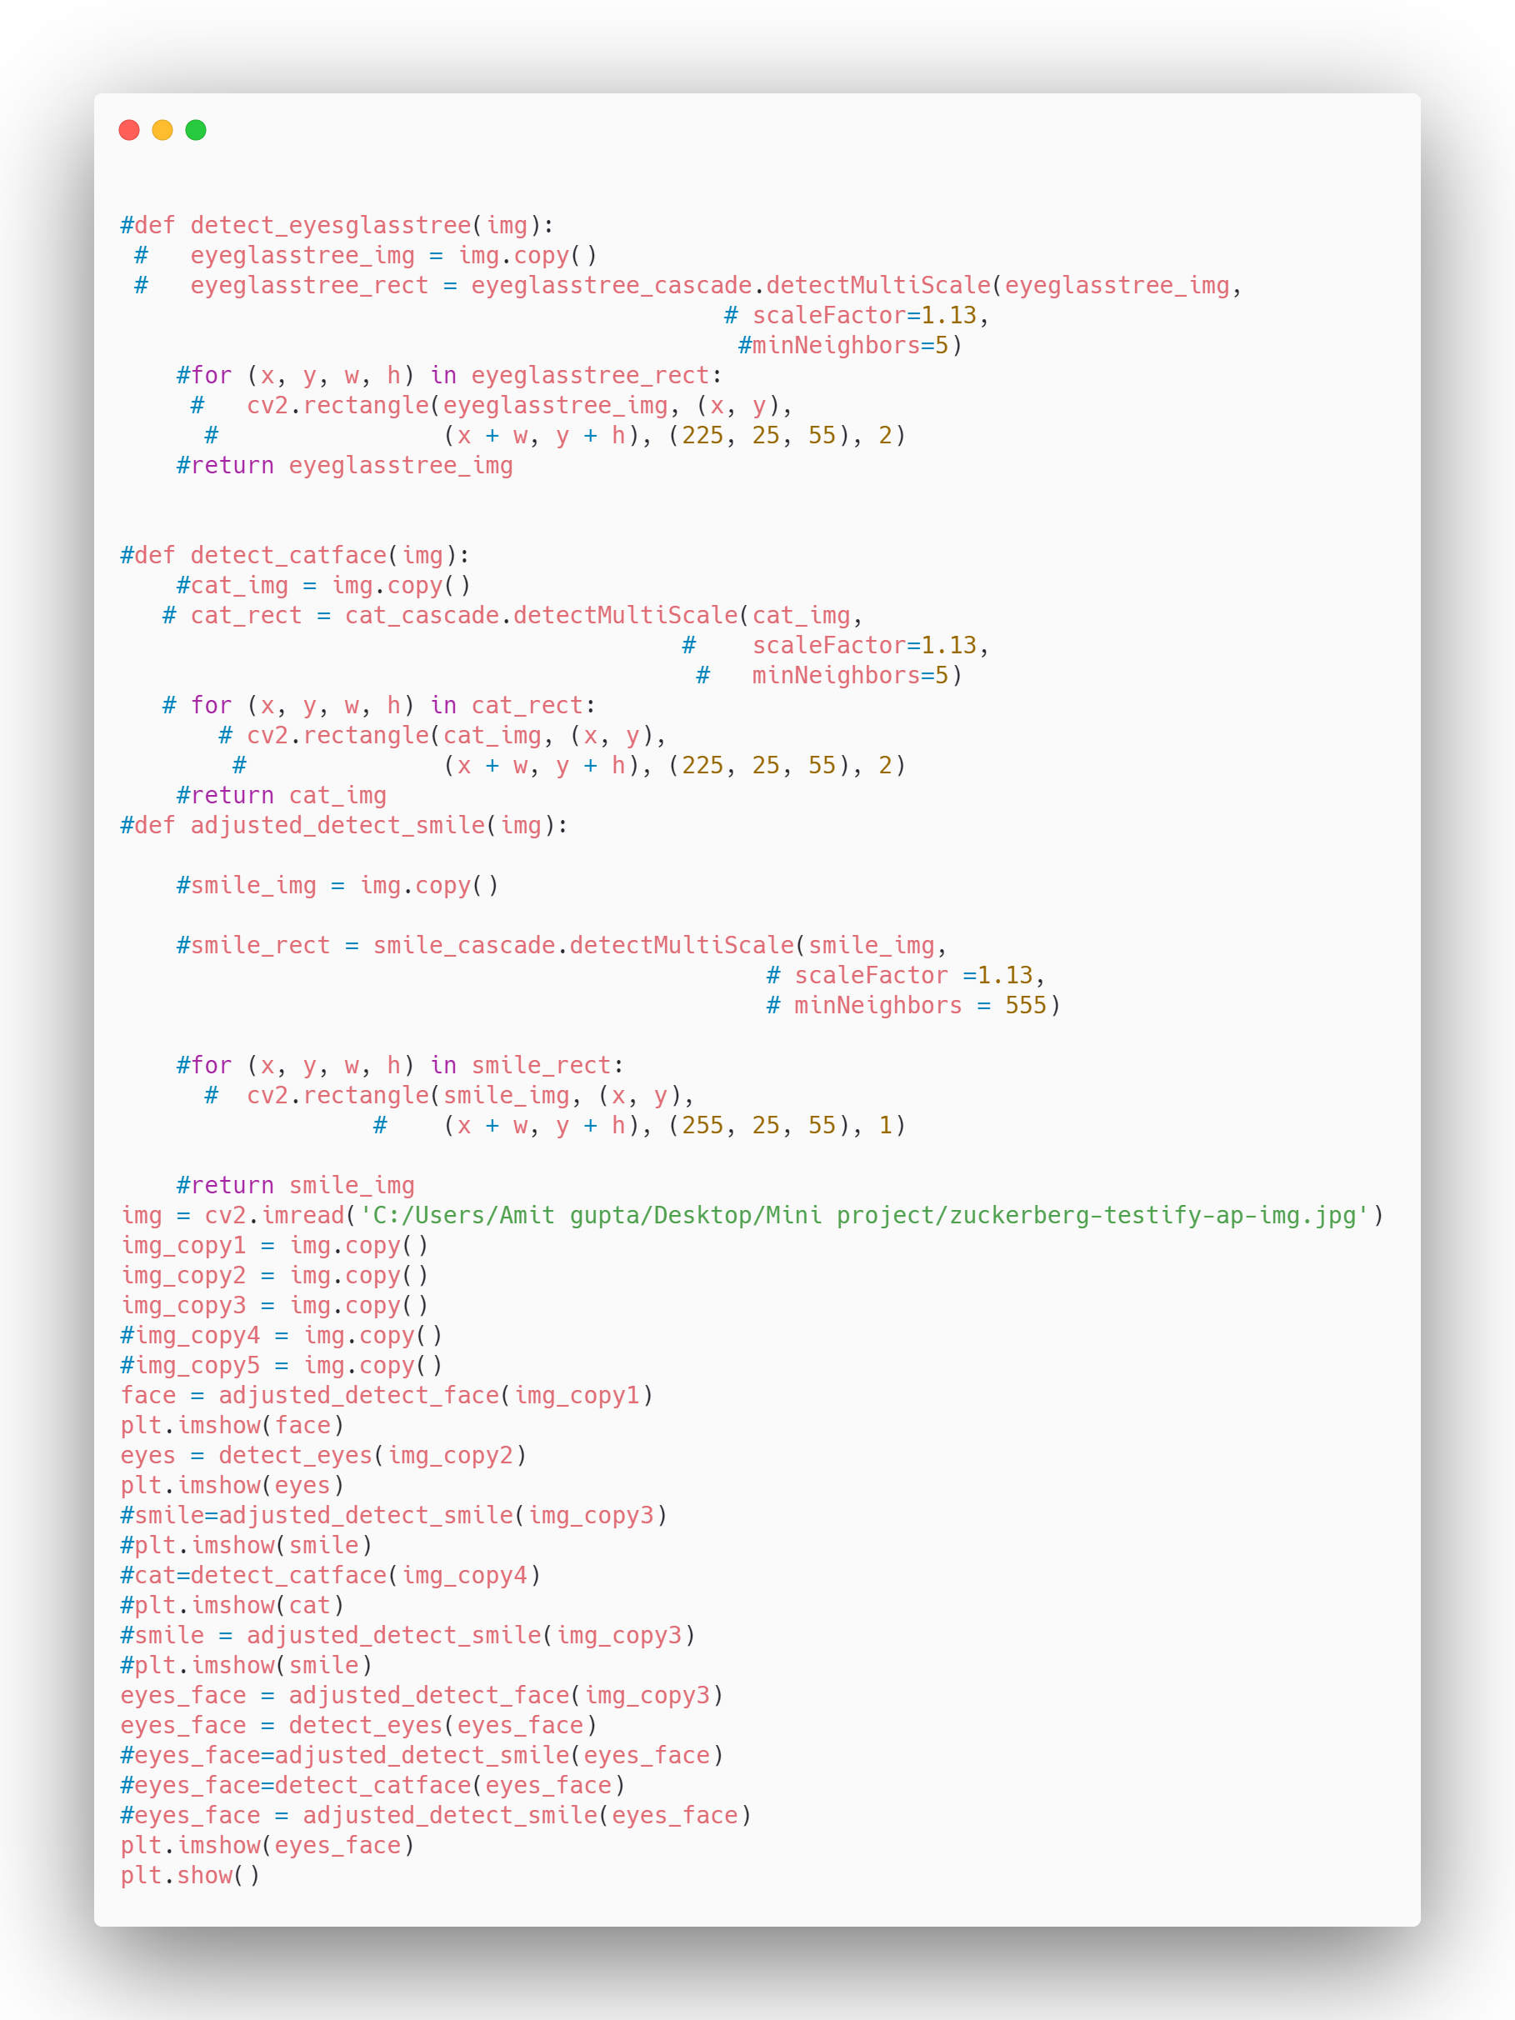

Facilities required for proposed work Hardware Requirements

1.Web camera

Software Requirements

1.Opencv 2.0

2. Python 3.5

3. C++ visual studio

References

[1] <https://facex.io/index.html>

[2] C. A. Hansen, “Face Recognition”, Institute for Computer Science University of Tromso, Norway.

[3] M. D. Kelly. Visual identification of people by computer. PhD thesis, Stanford University, Stanford, CA, USA, 1971.

[4] T. Kanade. Computer Recognition of Human Faces, 47, 1977.

[5] W. Zhao, R. Chellappa, P. J. Phillips & A. Rosenfeld, “Face recognitions literature survey”, ACM Computing Surveys, Vol. 35, No. 4, December 2003, pp. 399–458.